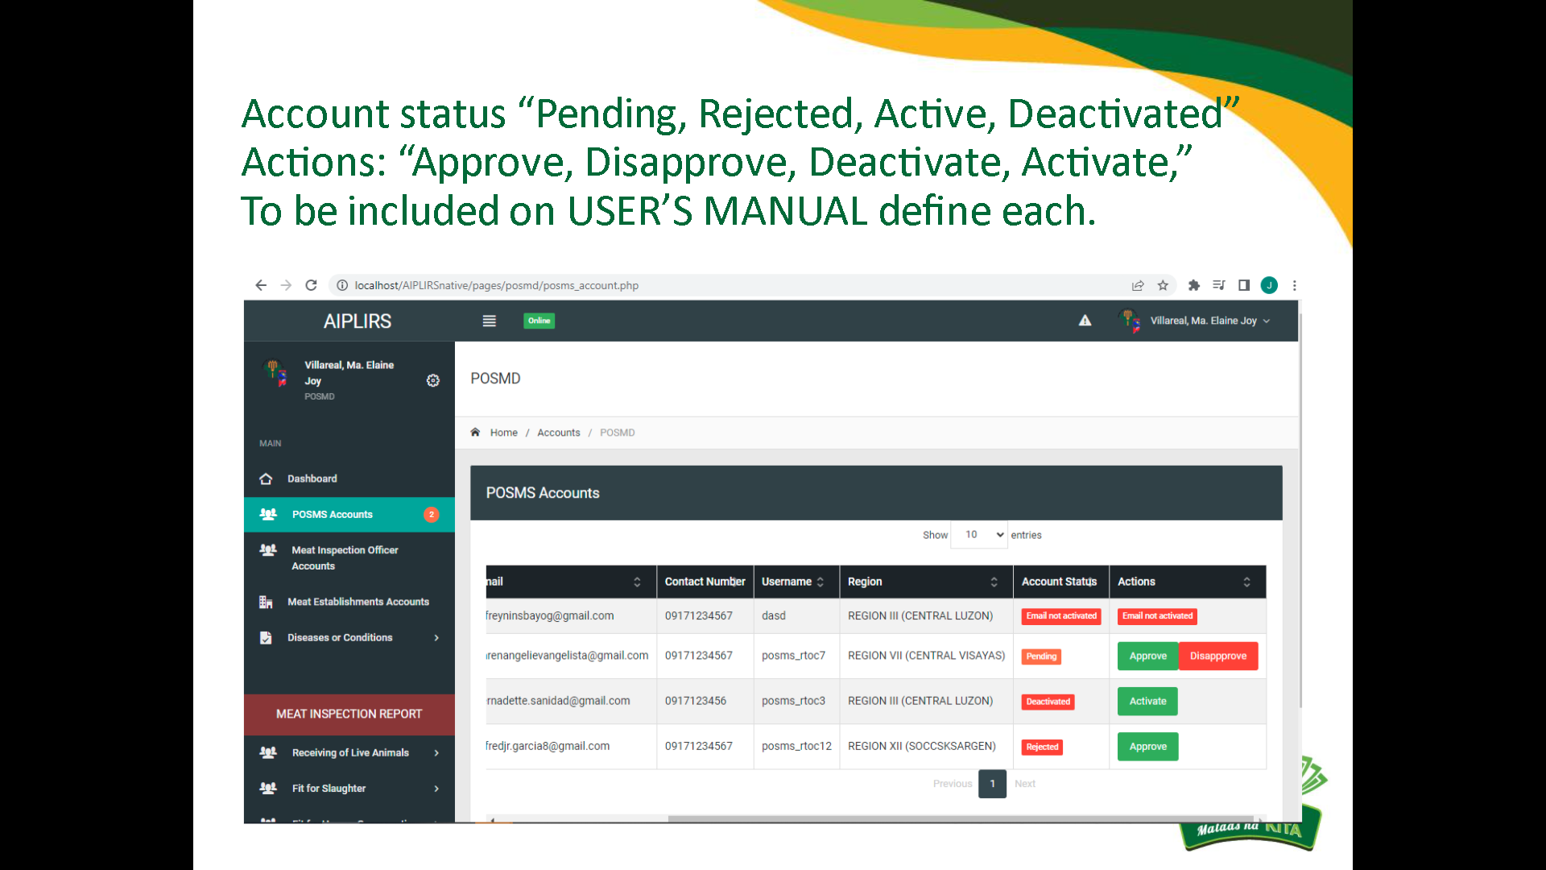

Resolved

August 10, 2022

Account status: change “rejected” to “disapproved”

Same with MIO / POSMS accounts

Change reject to disapprove

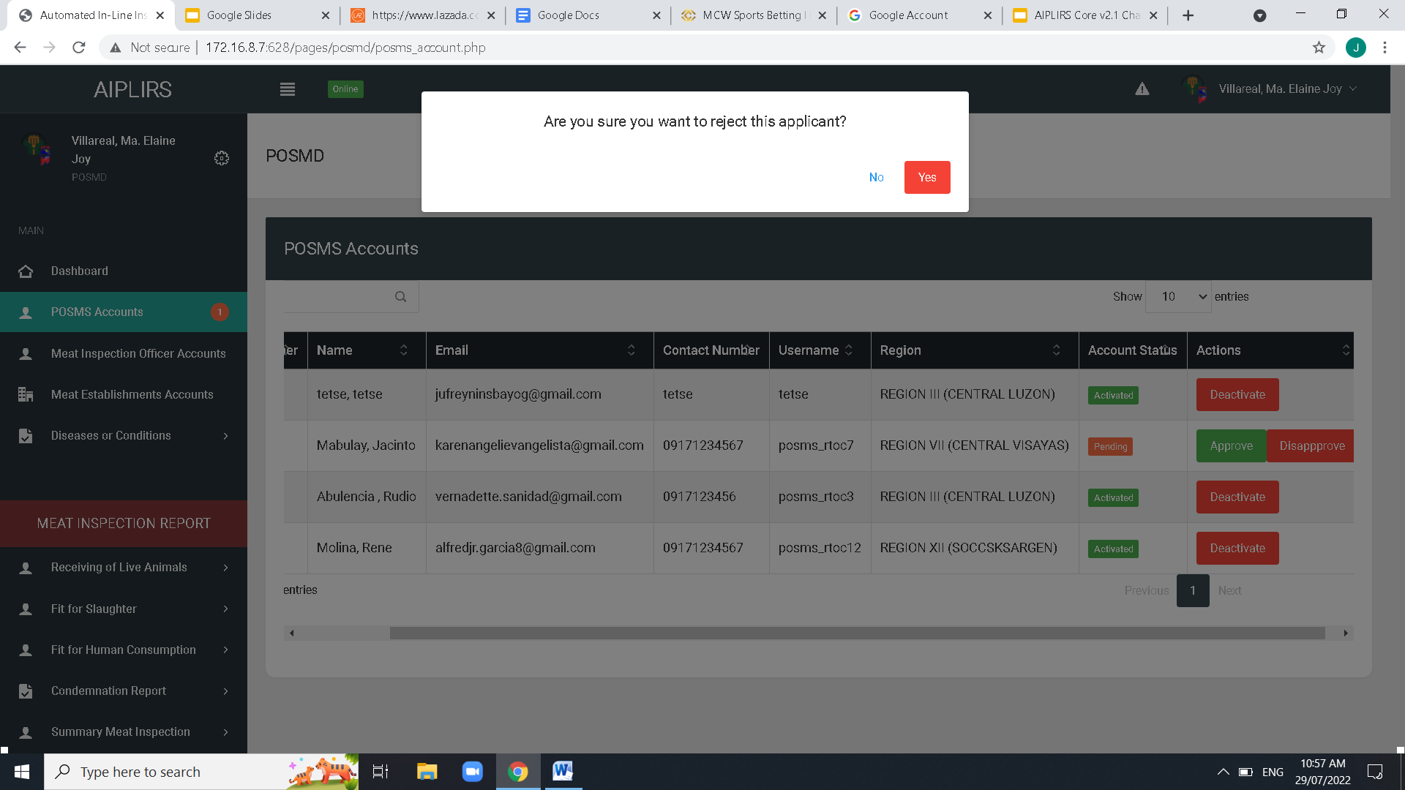

Resolved

August 10, 2022

Pending : color combination power point comment

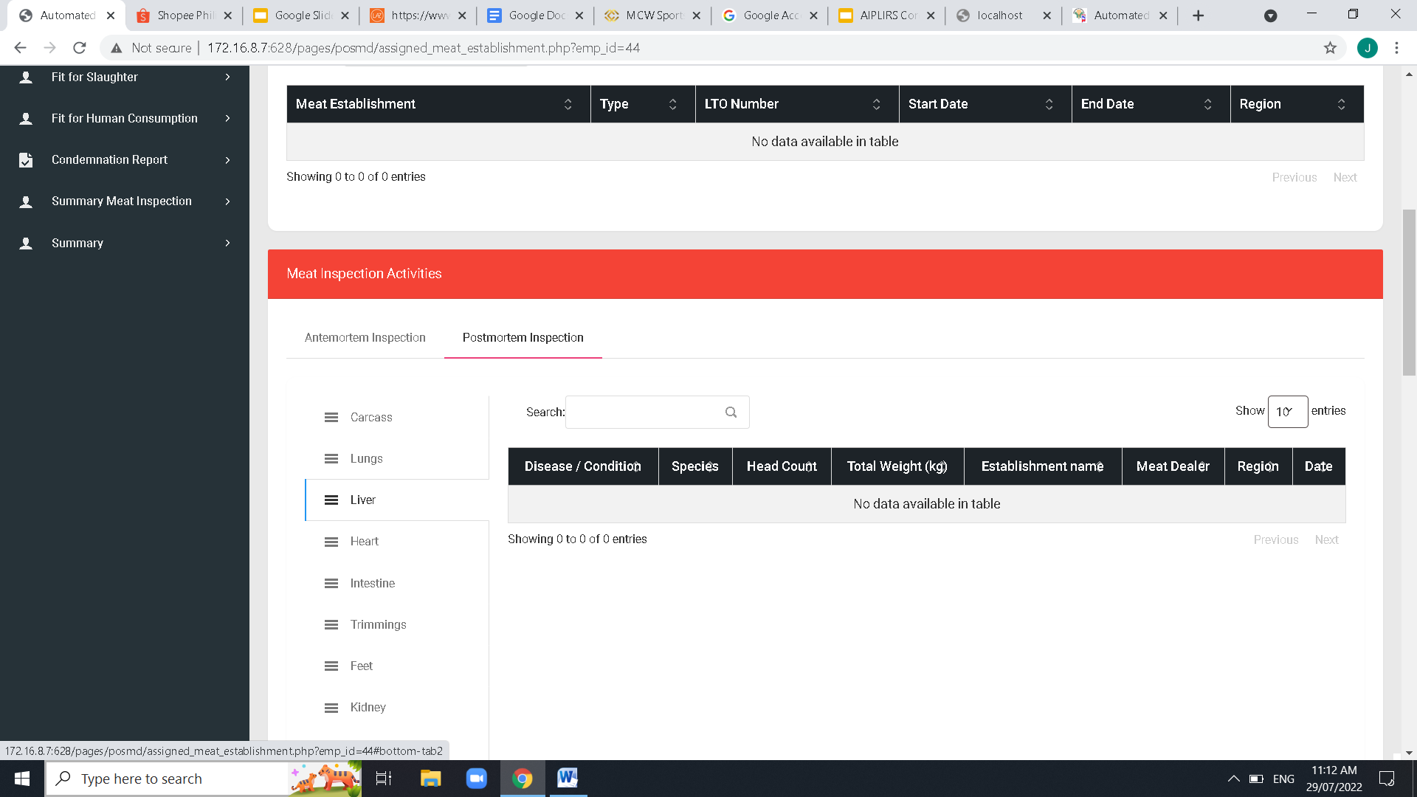

Resolved

August 10, 2022

Meat establishment

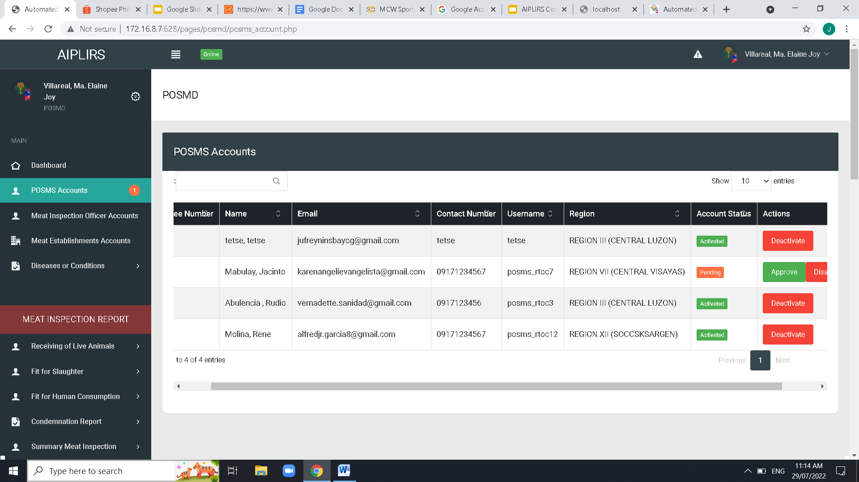

Resolved

August 10, 2022

Remove navigaton bar header

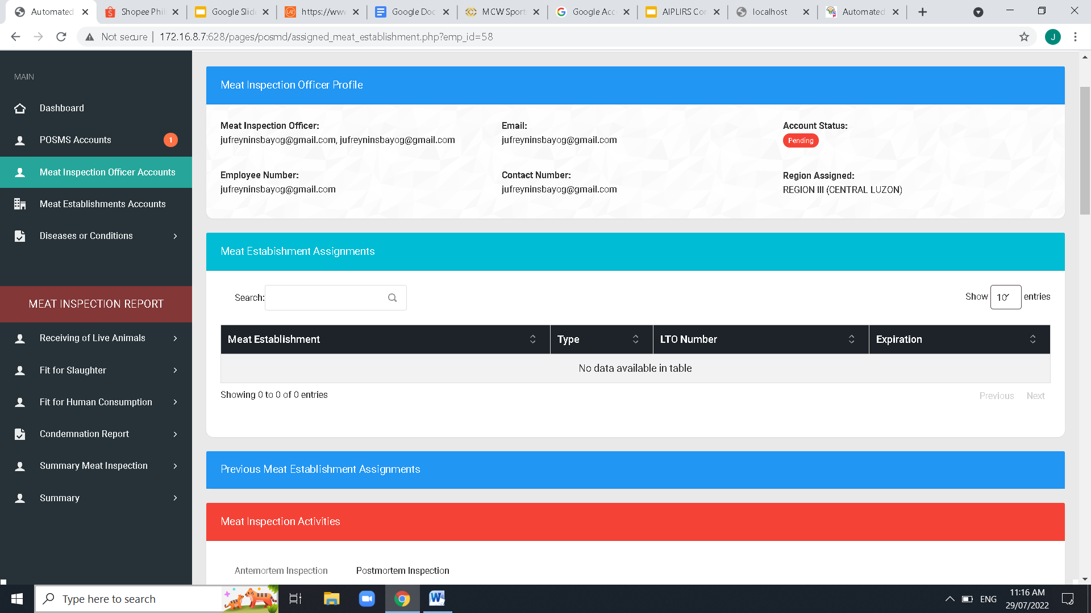

Resolved

August 10, 2022

Current Meat Establishment Assigments

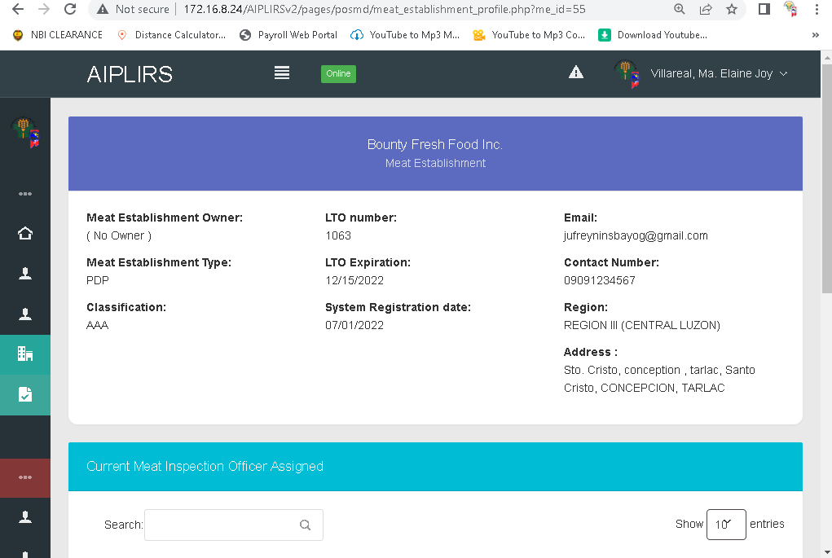

Pending for the registration page validation

August 10, 2022

No owner issue check database and make it required upon registration

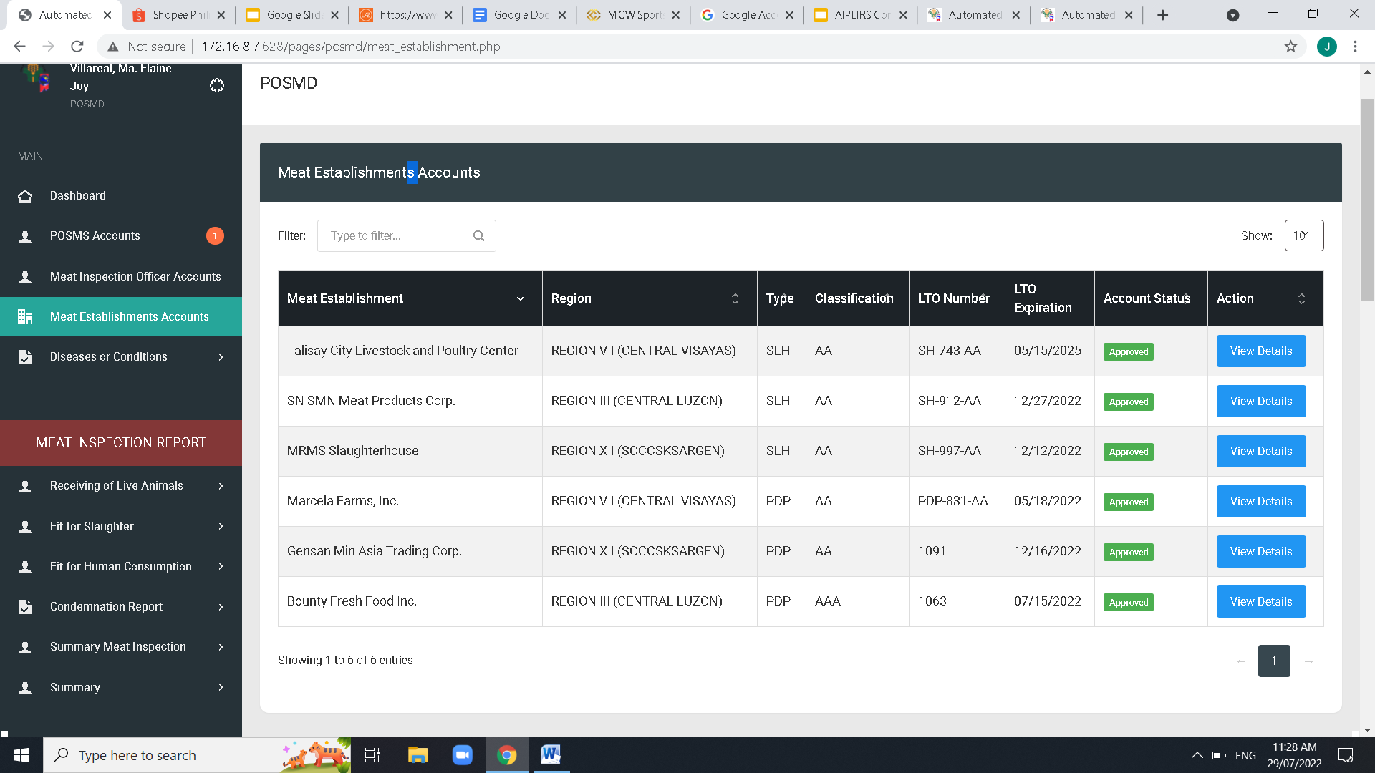

Resolved

August 10, 2022

Remove “s” Meat establishments

Remove “s” Meat establishments

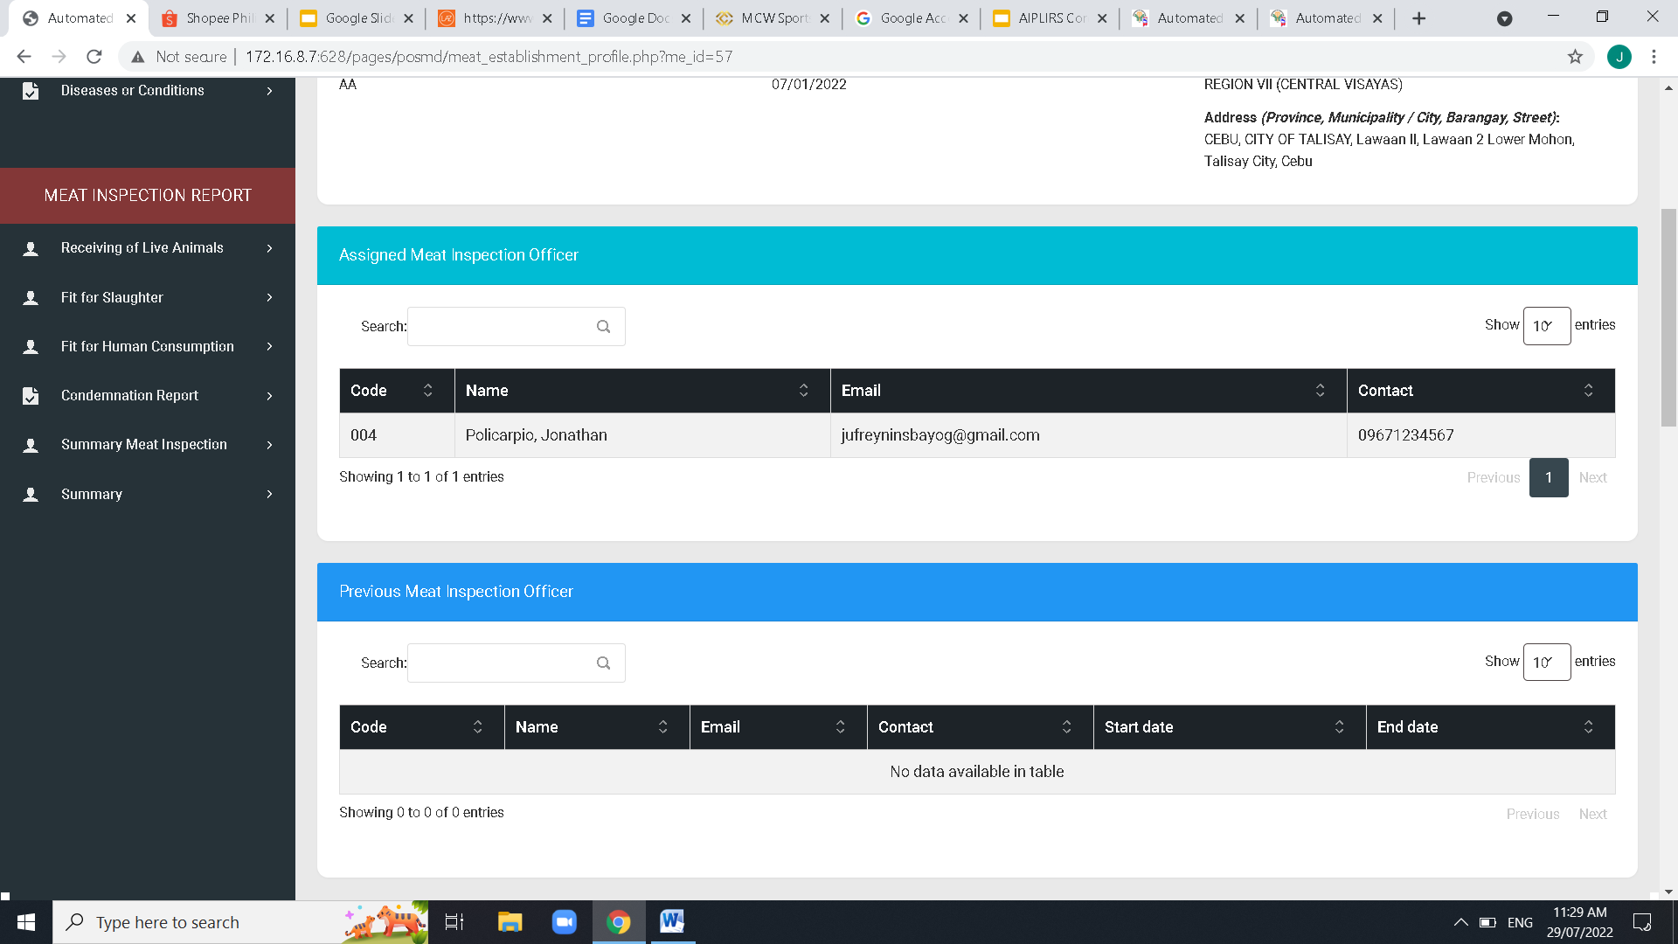

Change to “Previous Meat Inspection Officer Assigned” to Employee number

Change to “Current Meat Inspection Officer Assigned” AND “Code” to Employee number

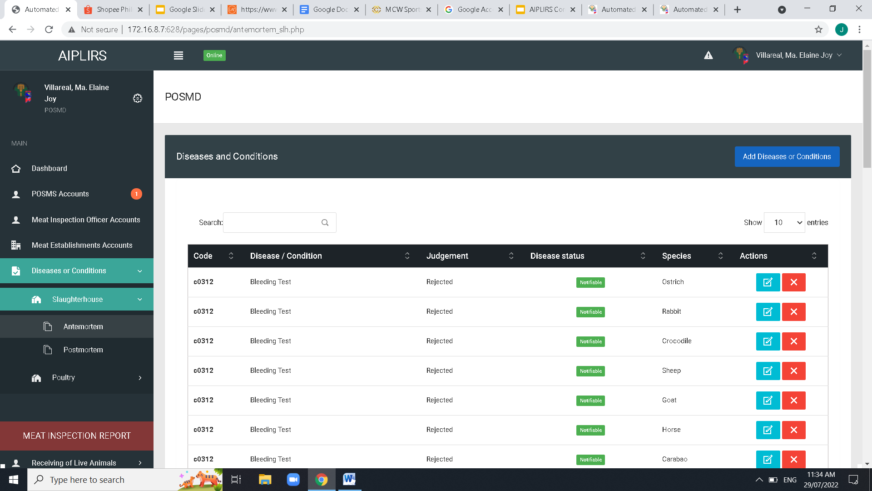

Resolve

August 10, 2022

Pending: for the position of button

Refer on messenger chat send by doc mej

Remove “s” disease or condition

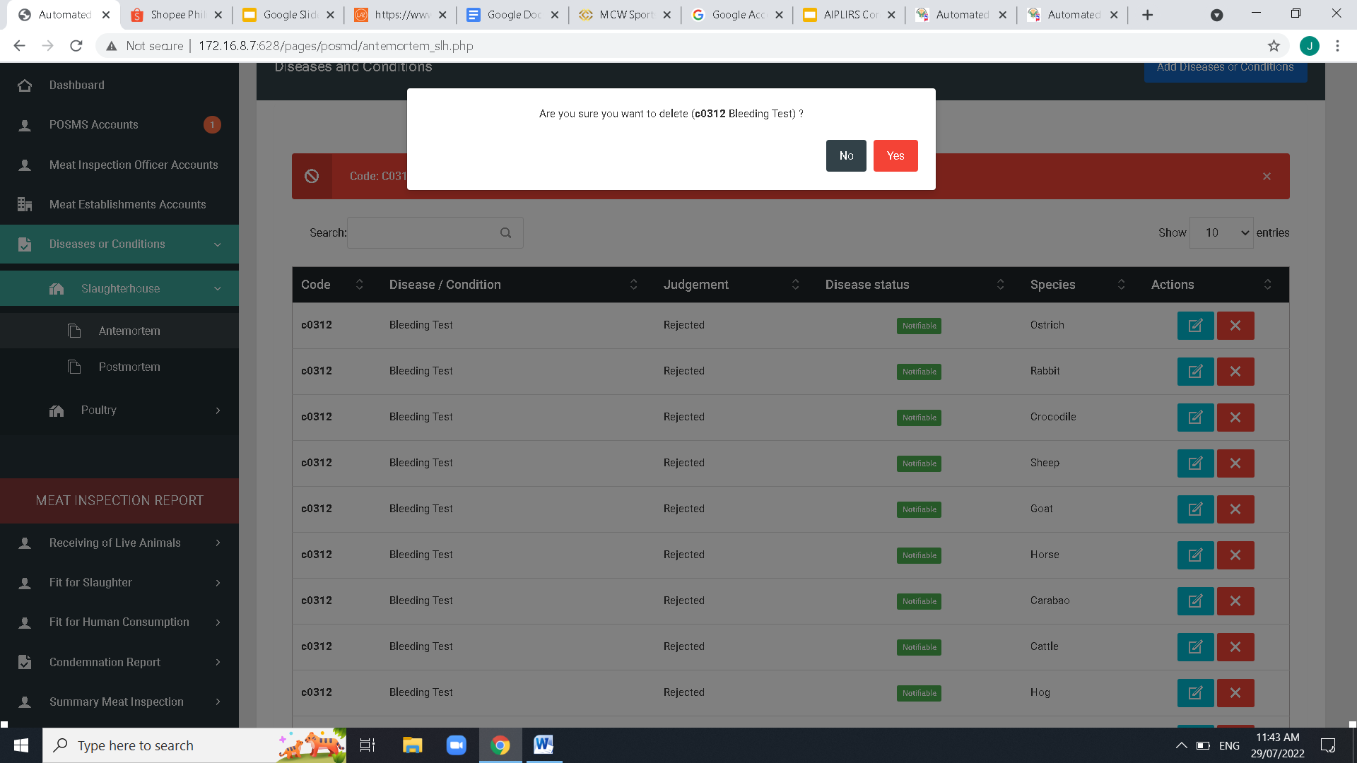

Pending

August 10, 2022

Center button modal

Change button color to Red- No / Green-Yes

TO ALL POP UP QUESTION

Change Font size into a readable size

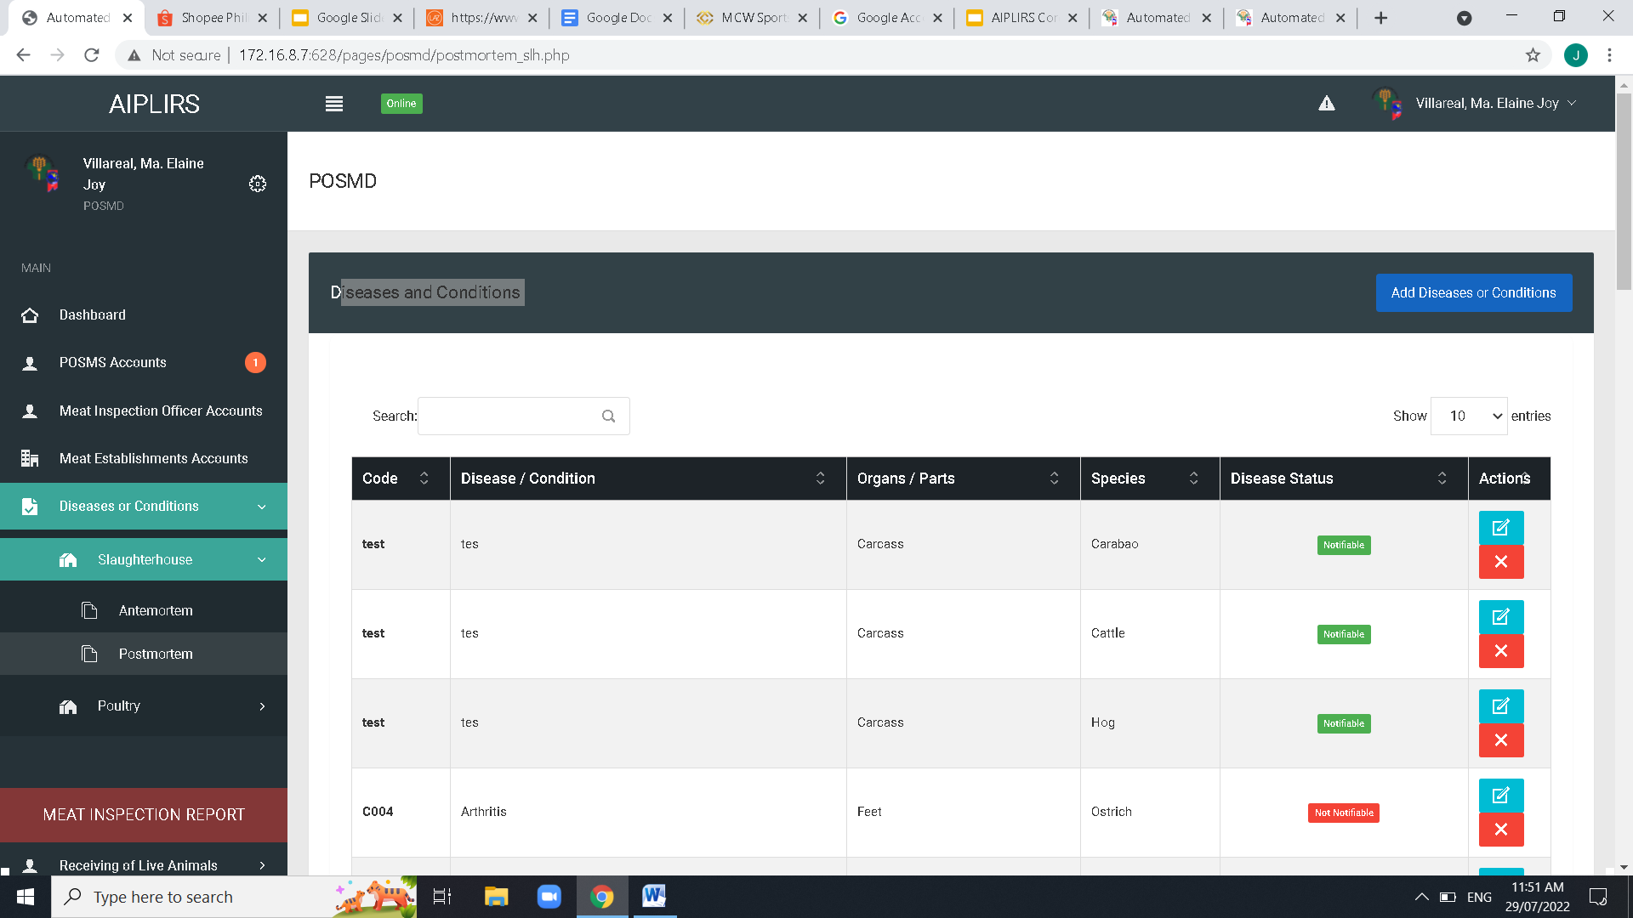

Pending

August 10, 2022

Same issue on SLH antemortem ispection

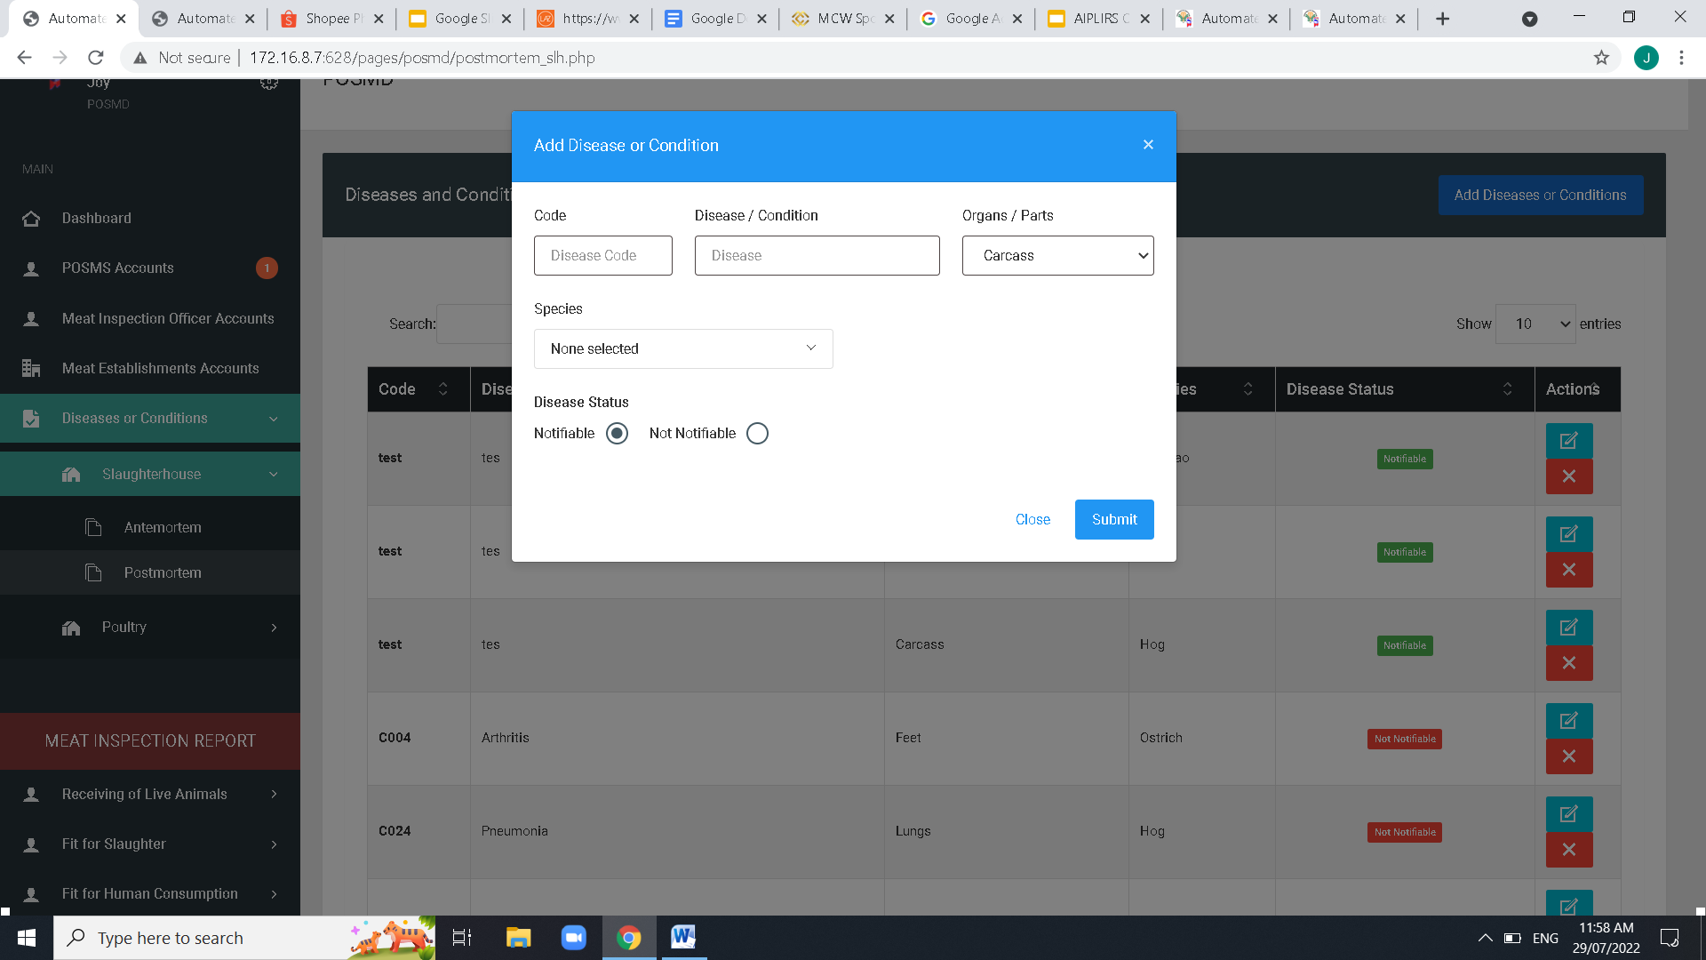

resolved

August 10, 2022

before species dropdown add judgement dropdown

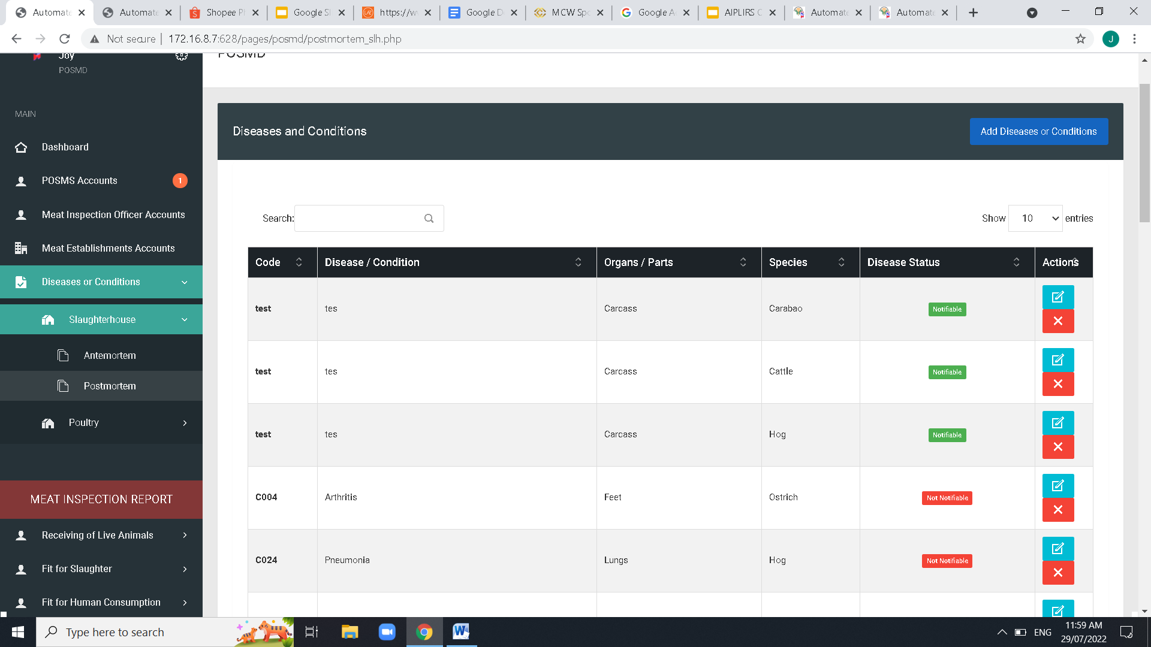

Pending on AM Pages both SLH PDP

Resolve on PM pages both SLH PDP

August 10, 2022

Table Column order: Code - Disease / Condition – Judgement – Organs/Parts – Species- Disease Status-ACTIONS and Spacing of Table data

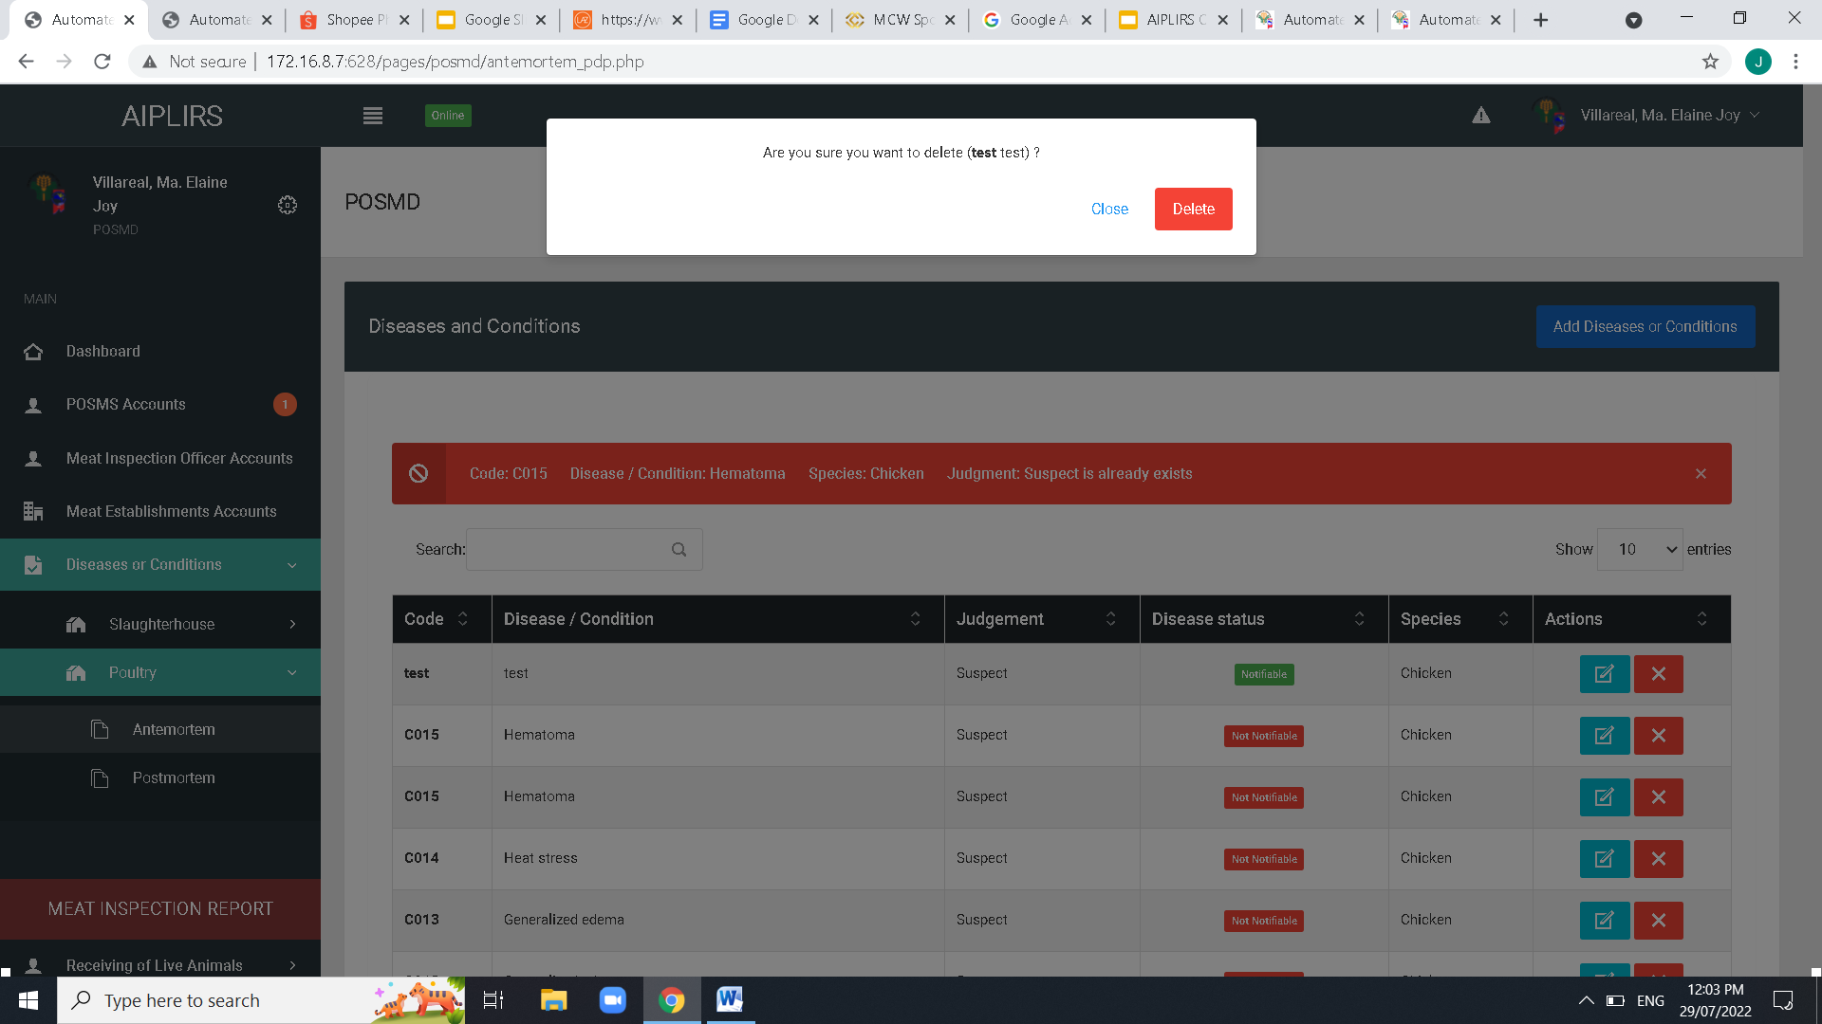

Pending base on power point

August 10, 2022

Center button modal

Change button color to Red- No / Green-Yes

TO ALL POP UP QUESTION

Change Font size into a readable size

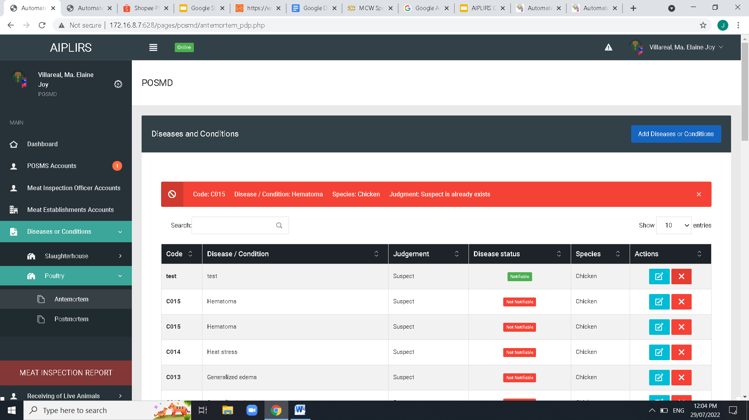

Resolve

August 10, 2022

SIDEBAR label: poultry change to Poultry Dressing Plant

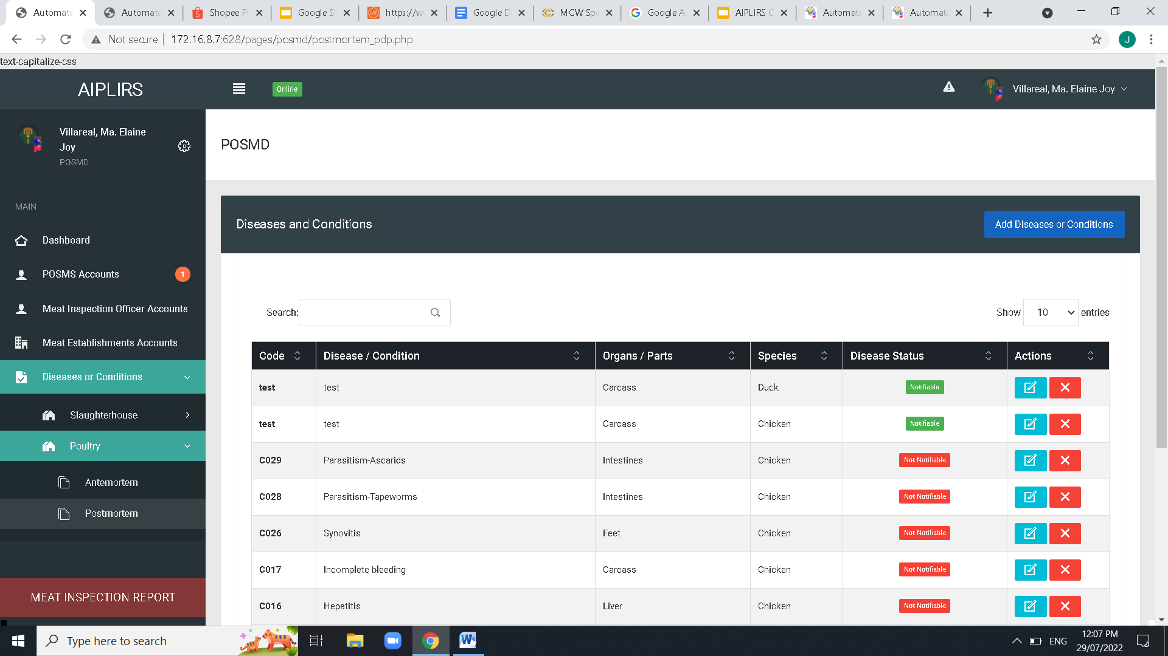

Resolve

August 10, 2022

Table Column order: Code - Disease / Condition – Judgement – Organs/Parts – Species- Disease Status-ACTIONS and Spacing of Table data

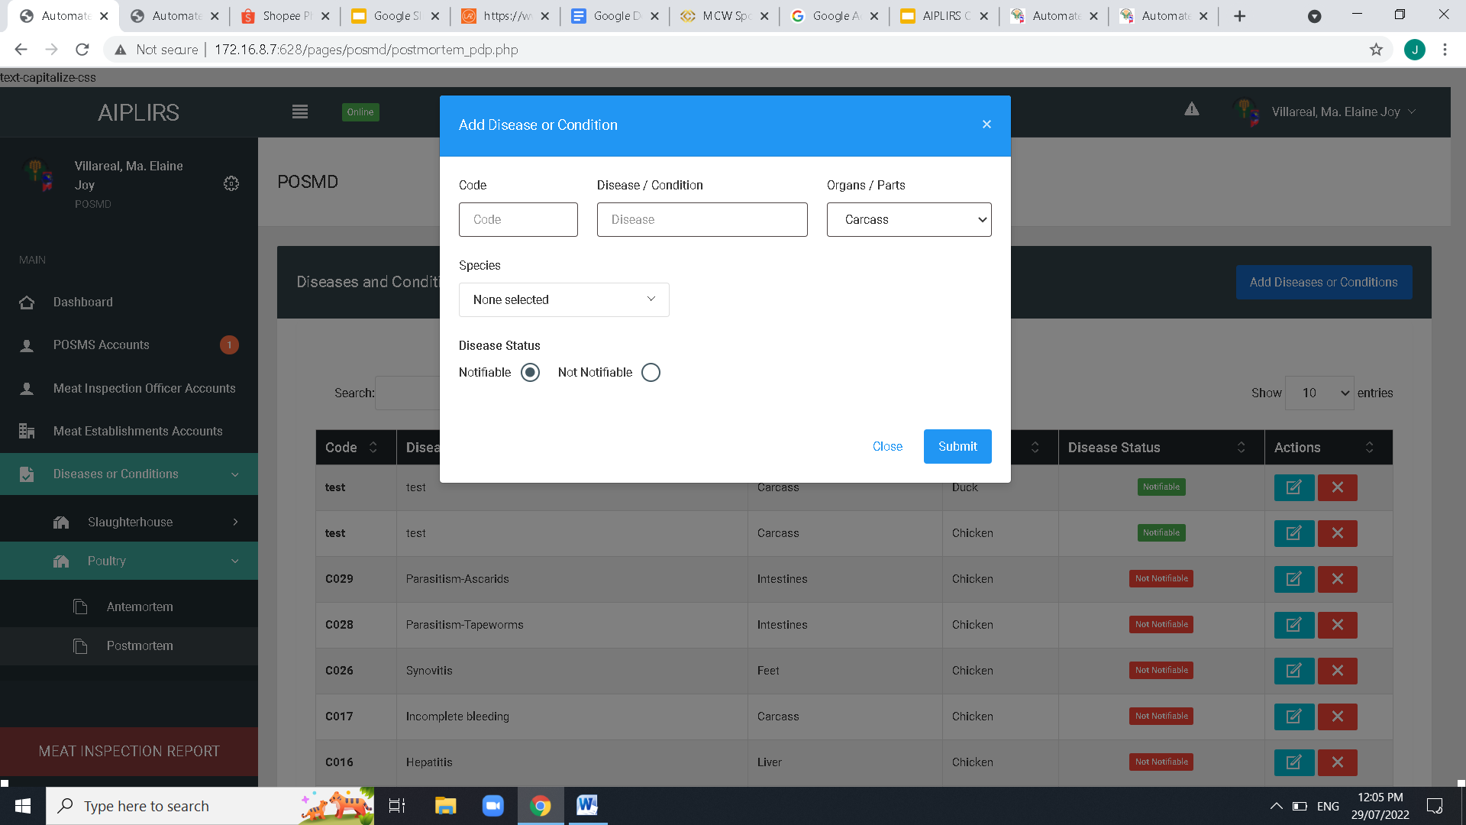

Resolve

August 10, 2022

Add judgement dropdown before species

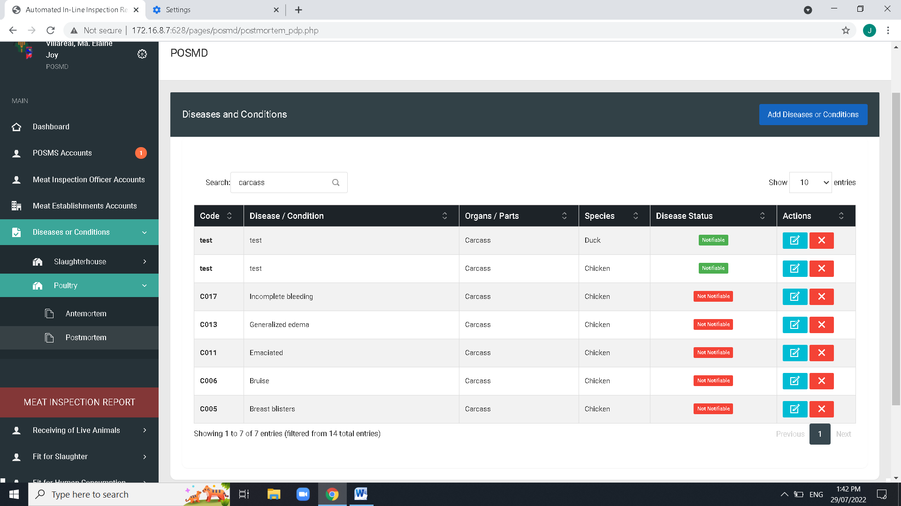

Resolve

Pending based on power point

August 10, 2022

Create a dropdown filtering of each column on disease and condition and the order of the dropdown similar with the table header

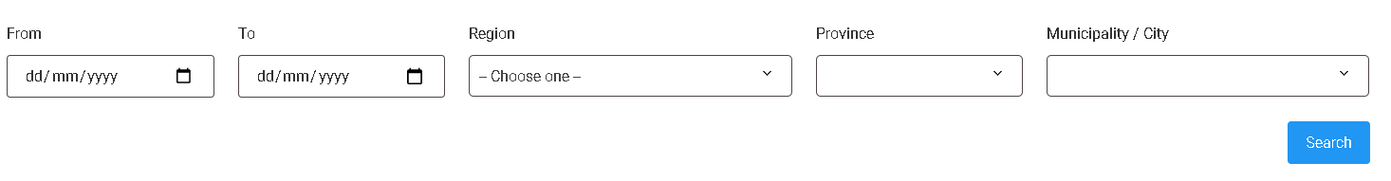

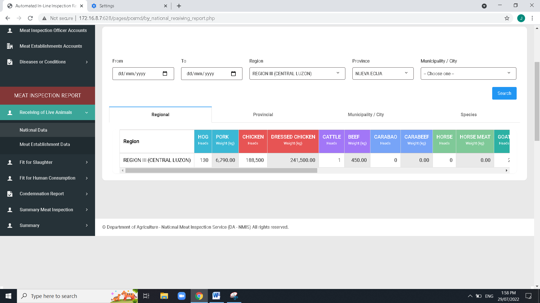

Resolve

Pending based on power point

August 10, 2022

On the top of the table add table for the total all Meat inspection report of receiving,slaughter, fit for human consumption

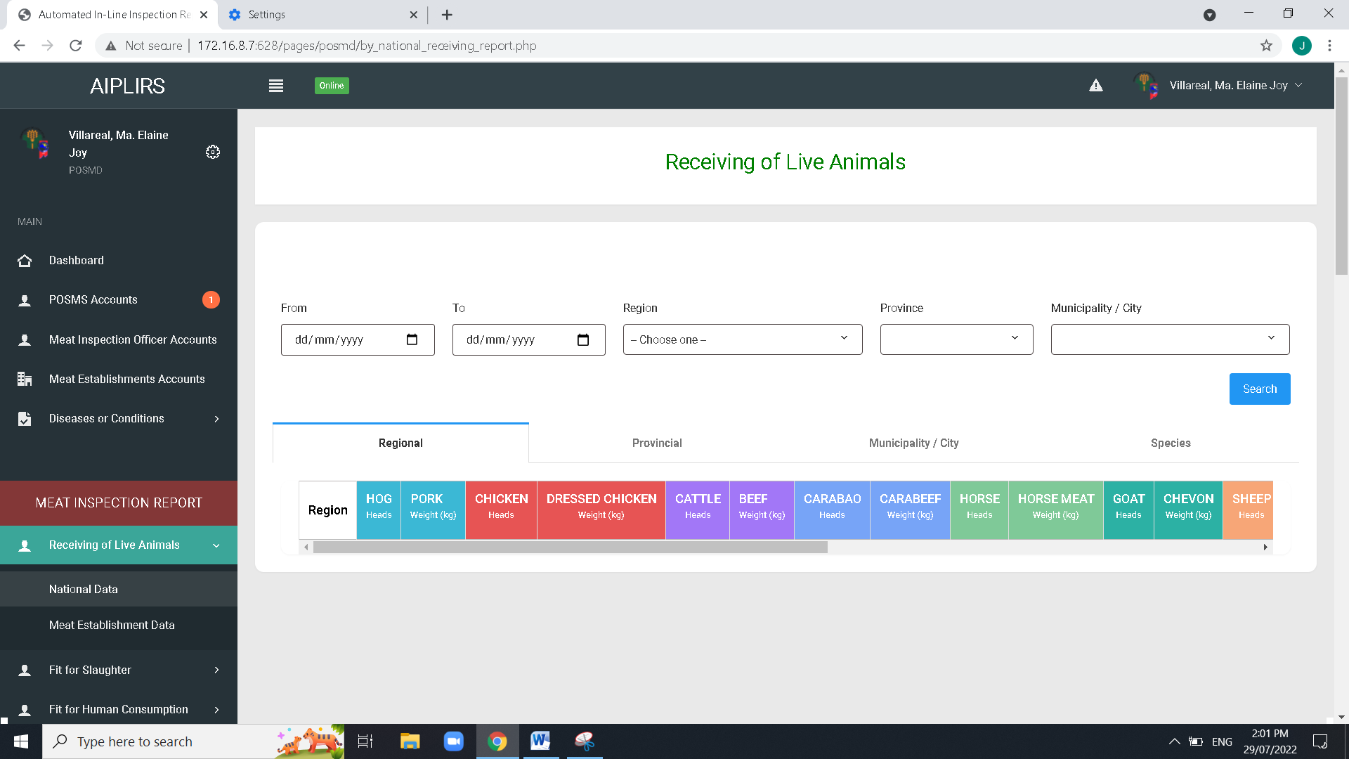

Resolve

August 11, 2022

Remove “LIVE” on the sidebar label

Remove “LIVE” on the header title

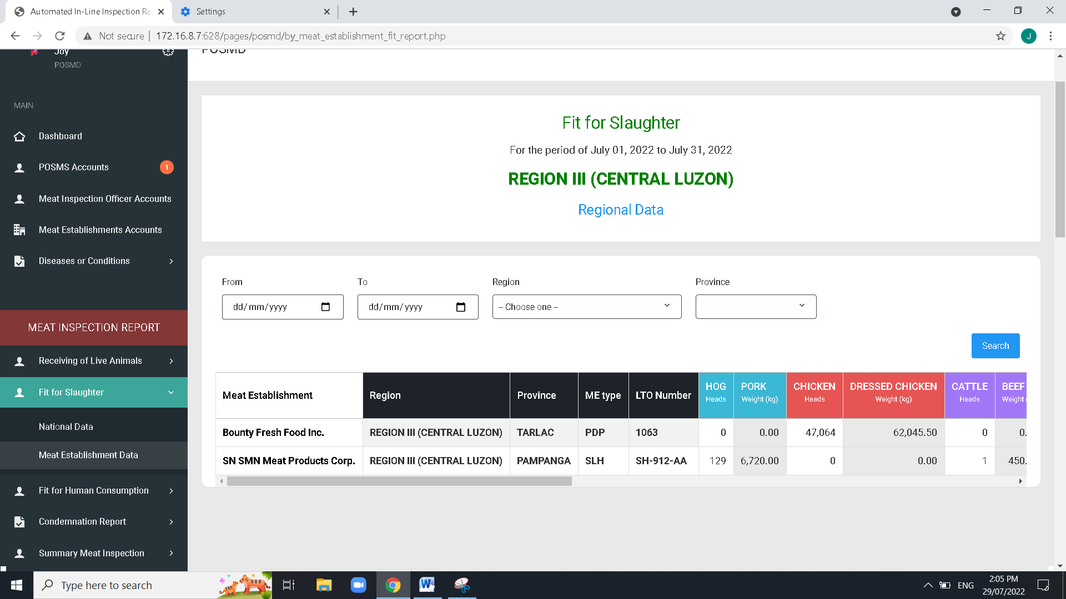

Pending: based on power point

August 11,2022

Remove column Region in all summary of meat establishment

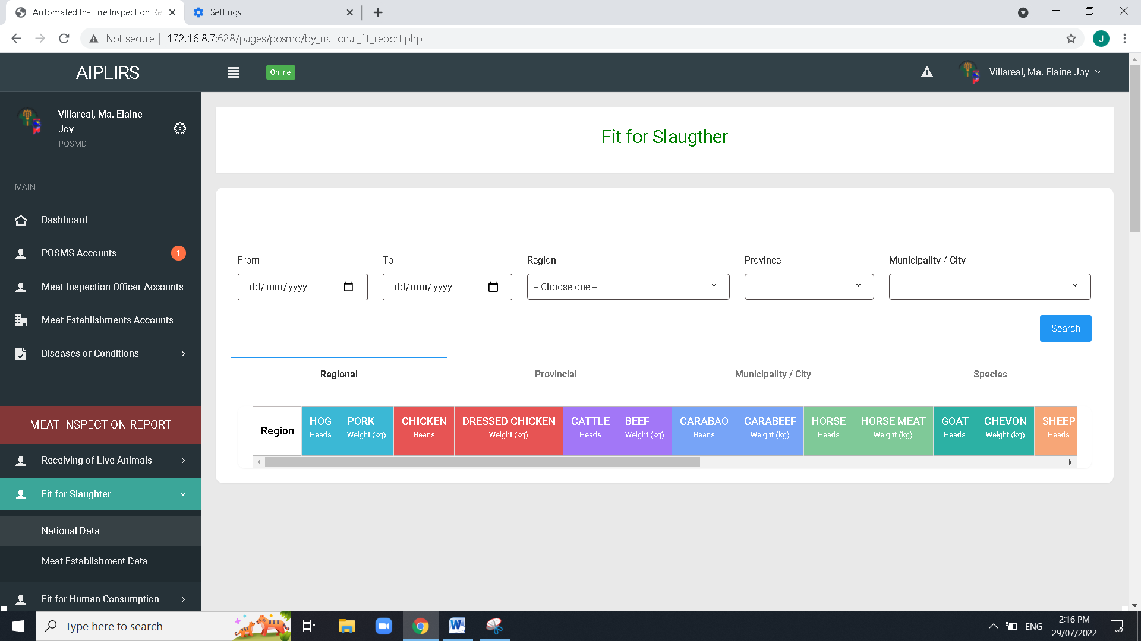

Resolved

August 11,2022

Spelling ”slaughter”

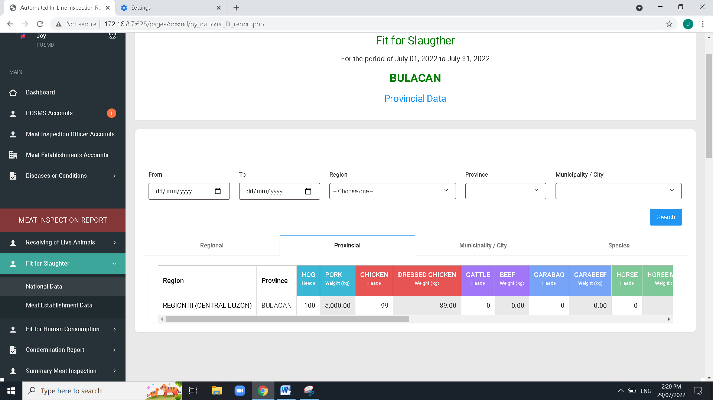

Resolved

August 11,2022

Remove Title. Regional, province, city, national

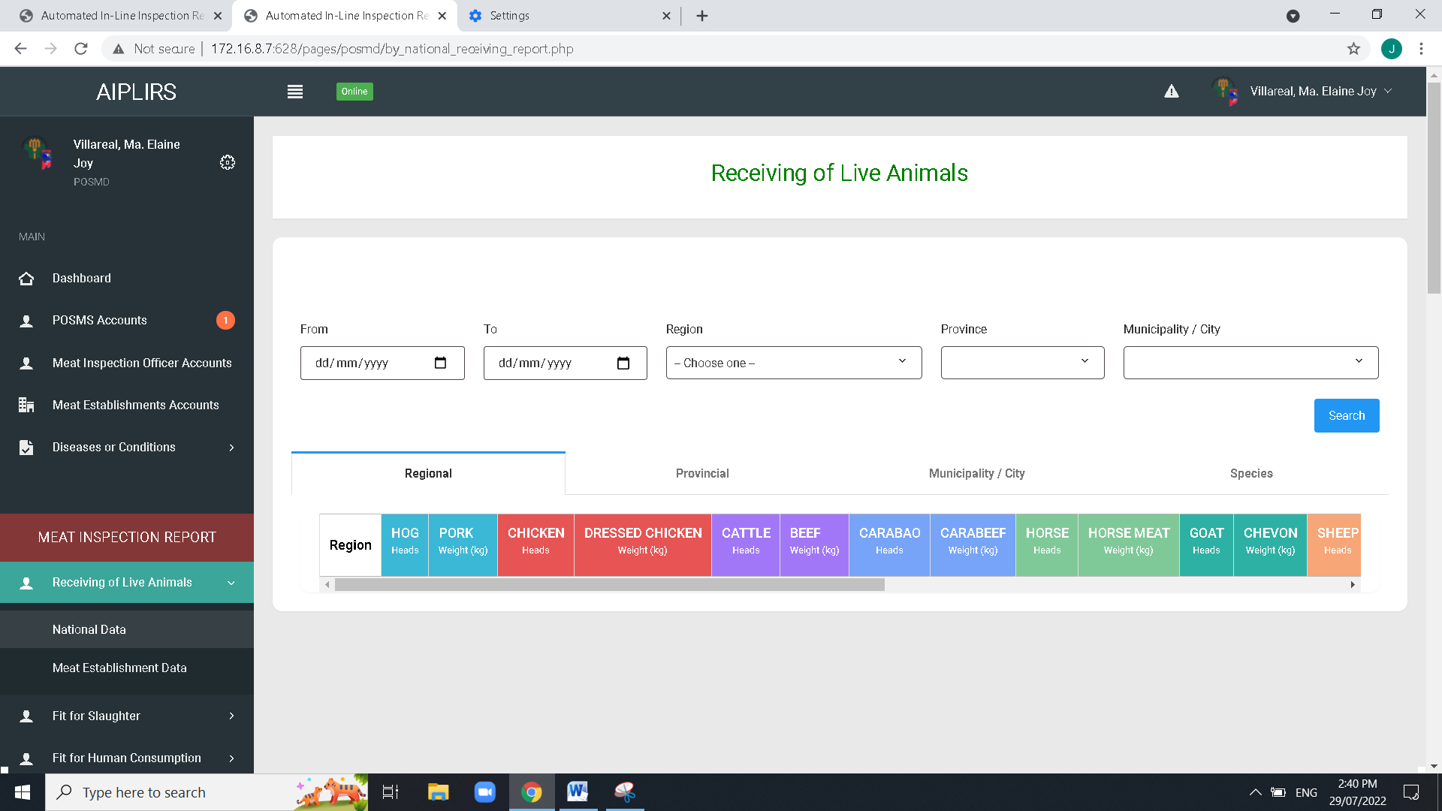

Resolved with revise User interface

August 11,2022

Remove tabs and leave tab for species… in all reports (Receiving, Fit for Slaughter, Fit for human Consumption)

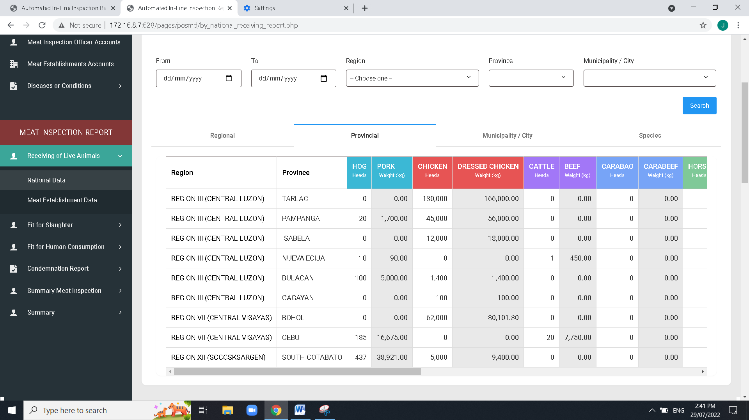

Revise User interface

August 11,2022

Add column for the Municipality / City in all repots (Receiving, Fit for slaughter, Fit for human consumption)

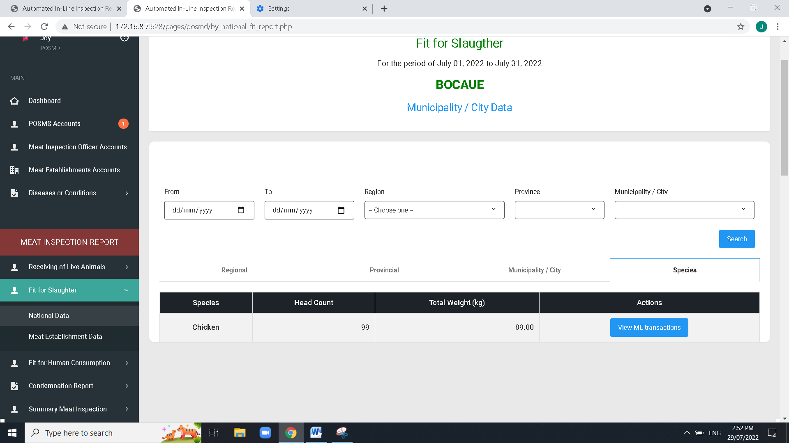

Revise User interface

August 11,2022

Apply this title for the addition column table column below.

Additional column:National data / Regional, Provincial, muni /city/ based on the filter fields above

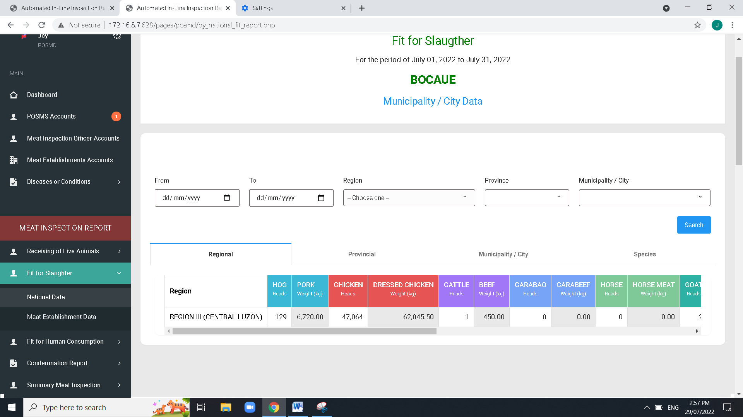

Resolved

August 11,2022

Change horizontal tab title:

Regional to location

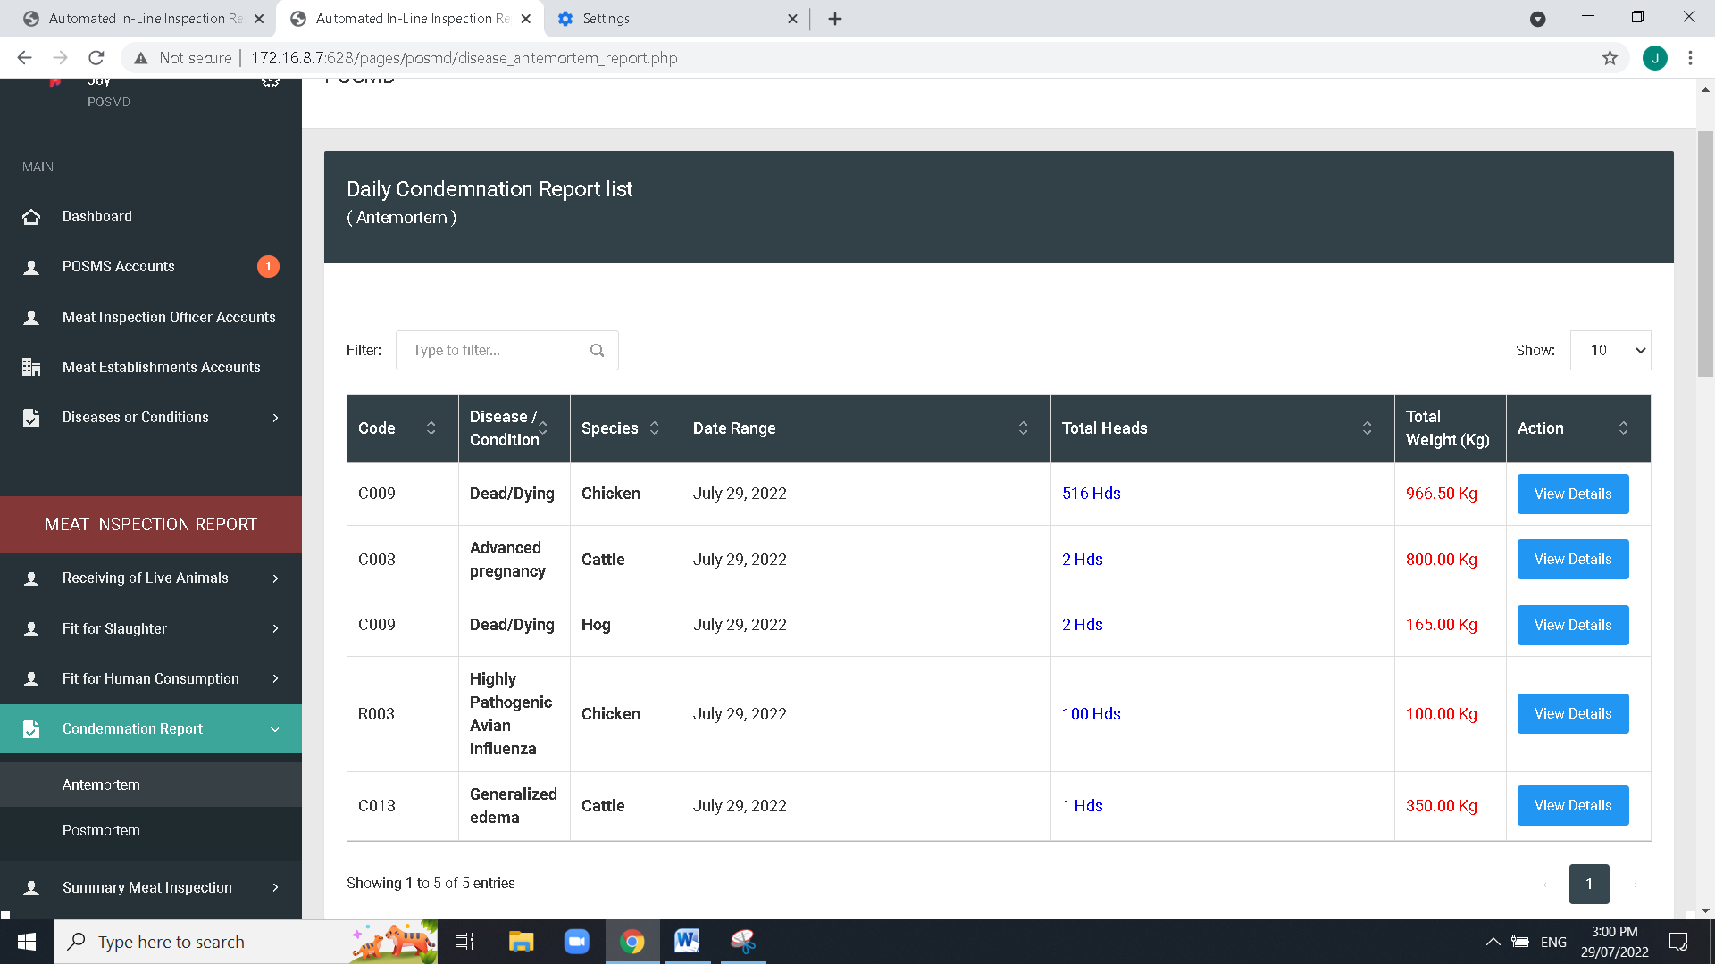

Resolved

August 11,2022

Date range to date

Create a filter for the condemnation

Change to “Ante-mortem Condemnation Report”

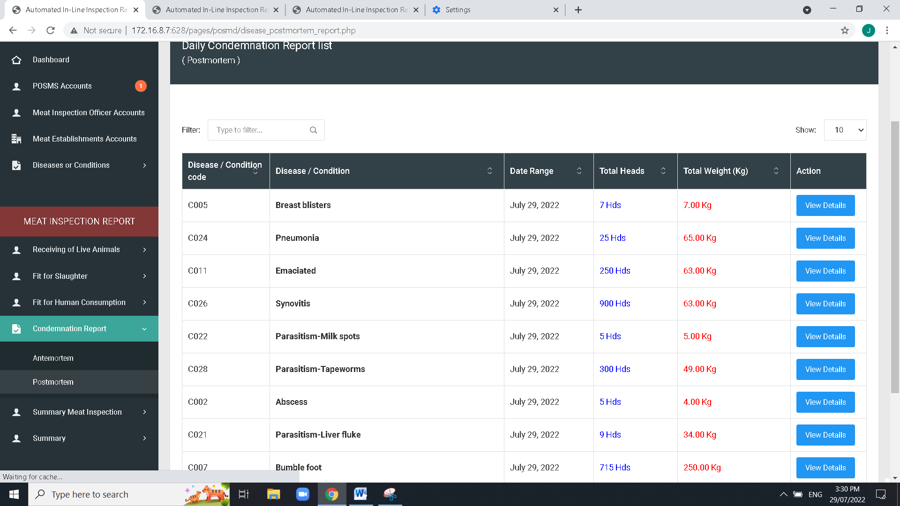

Resolved

Pending : total in “total head count”

August 11,2022

Head count, small “K”

Change to “Code”

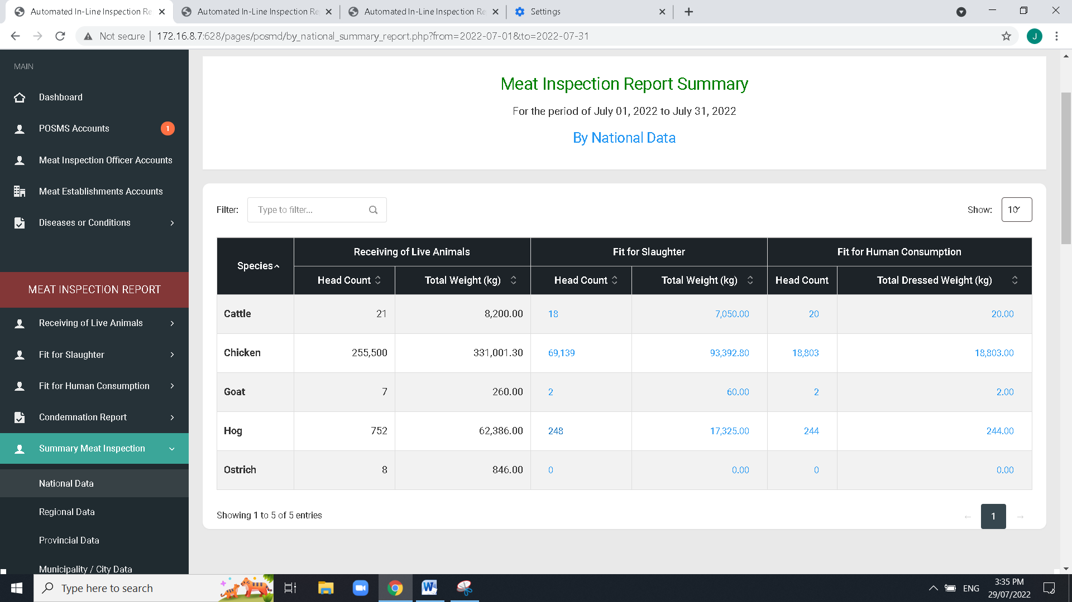

Resolved

Pending : total in “total head count”

August 11,2022

Same issue with the MIO revised on Localhost that the total result is based on head count Instead of total weight

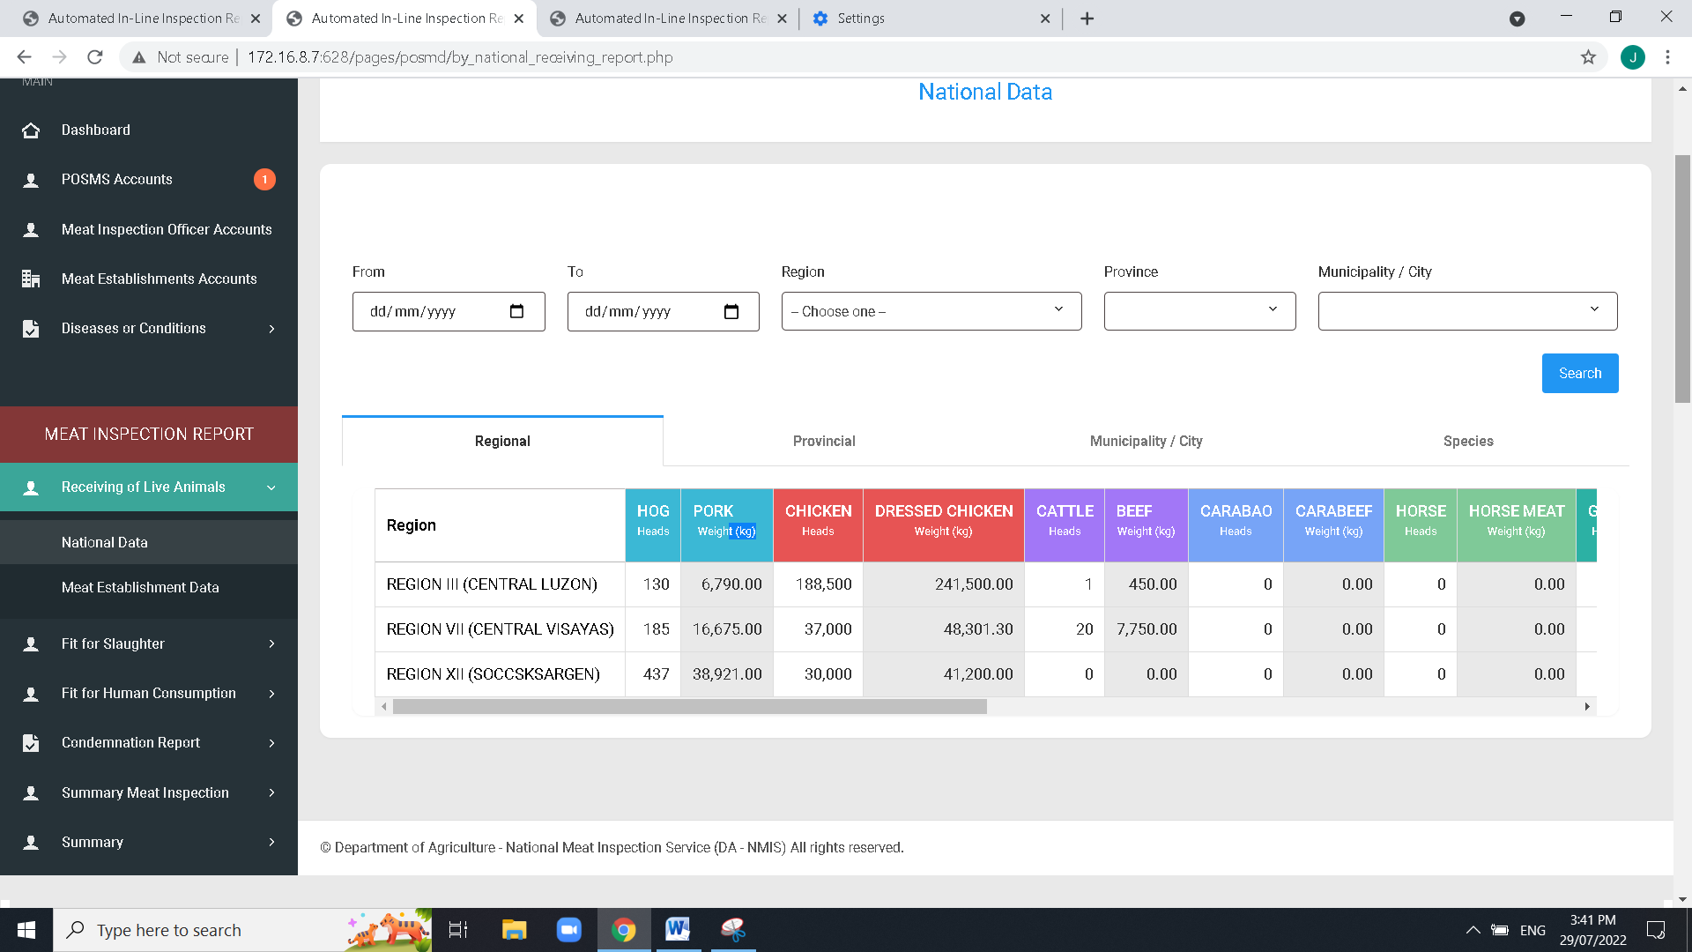

Remove “Summary” due to the similarity on the page of Fit for human consumption (redundant)

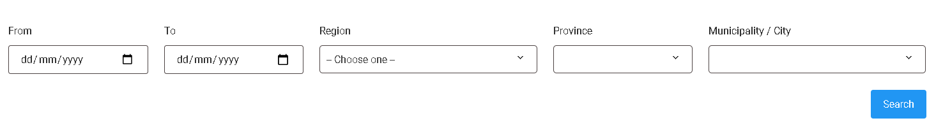

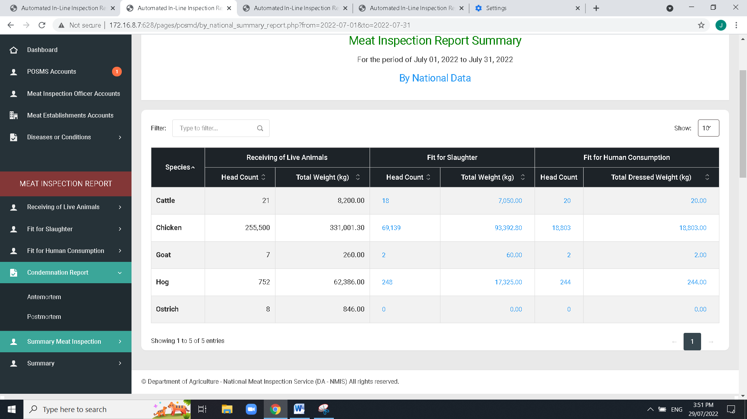

Sidebar label: “Meat Inspection Report Summary”

Add “type of meat”

To think of what user interface to be apply , and filtering dropdows such as: From – to date, Regional, Province, City,Species